Handbook of Good Practice (by Beata Lenartowicz from POLAND)
We are working on a fantastic project and as a result a large number of artworks are created. Our pupils are the authors of these beautiful pictures. I know that we all are very proud of them so art galleries are organized at schools to display their works. Why don't we share the pictures with others by creating jigsaw puzzles?
Jigsaw puzzles made out of the pupils artworks are very attractive and enjoyable activity.
At first ask your pupils to draw, paint or create a picture using the computer or tablet (you can also use already existing pictures). To use the artworks you have to have them on your computer. Then use online puzzle maker to create jigsaw puzzles. www.jigsawplanet.com is an easy to use tool.
1. Create an account ( without the account you can create puzzles but you will not be able to make any changes in the future)
2. Click on 'Create' button
3. Brose and choose the picture you want
4. Upload the picture
5. Type the title of the picture
6. Choose the numner of pieces you want to create
7. Choose the shape
8. Create
9. Share
10. Choose 'embed'
11. Copy embede code
12. Paste the embed into the page / twinspace

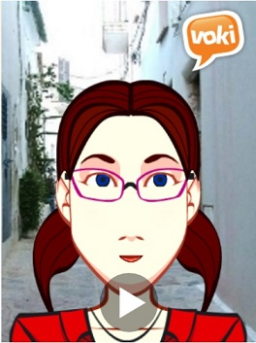
Voki is a FREE service that lets you create customized speaking characters. It is creative, easy-to-use tool that helps motivate students and improves lesson comprehension and student participation.
Why is it beneficial to create speaking Avatars in the classroom or use them as an effective learning tool?
•engage students with interactive activities
•introduce ICT in a fun way
Registration (to register you need an email account.)
http://www.voki.com
How to get your own voki: It’s very easy! Using the simple interface, customize the look of your Voki. Choose your head, clothes, and accessories. Give your Voki a voice and add a background. And your voki is ready!
What can we use VOKI for?
•Instructions: what to do, how to do…
•Introduce ourselves
•Describe something e.g. the landscape, the house (other pupils can draw what they hear)
•Give reasons and opinions
•Talk about likes and dislikes
•Practice conversation (questions and answers)
•Retell the stories
•Introduce a famous paiter/musician etc.
(A person - avatar, speaks about himself and the class or the partner school guesses which historical figure is being portrayed)
The Newspaper Clipping Generator
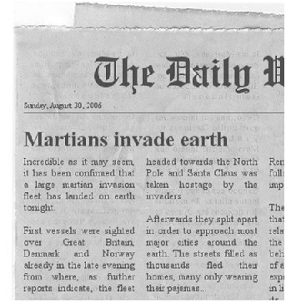
We all are obliged to disseminate the project through the wide range of channels. One of them can be a piece of newspaper which can be easily published on the internet as well.
•To create your own newspaper you don’t have to register. Just write the text, generate the newspaper, download the image and upload as an image on your twinspace.
•http://www.fodey.com/

