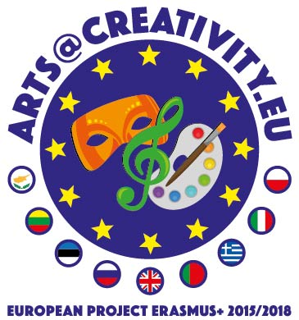
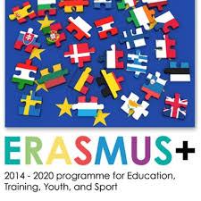
Erasmus+
Arts@creativity.eu Hymn
2015-2018
Save this moment please…(shhh)

Just draw and act,
Dance and sing
You’re a part of this
So…just be creative and feel this beat!

We are that lucky,
we belong in a school
That teachers care,
in what they do
They work in programs
to give us the chance
To be a student in Europe class
And this is all about, Erasmus+

Come on, come on clap the rhythm
Move your body in this music beat
Come on come dance with us
Be creative and feel relaxed.

Just draw and act,
Dance and sing
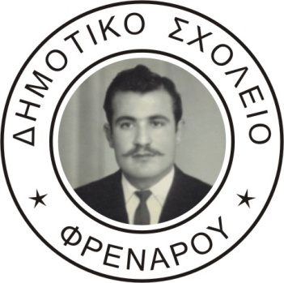
You’re a part of this
So…just be creative and feel this beat!
(music part to clap rhythm..)
We are a mixture of eight friends
All are special and do their best Greek bouzouki and the sirtaki
Polish culture with famous Chopin,
When Cypriots sing eshie vereve.
Venetians gondolas, inspire all
When Estonia manage wifi on top
Slovakians share some beers to get tough, to climb on Tatras mountains fast.
Lithuania paints graffiti on walls and Portugal with Ronaldo shouts the ball.
And that’s our team, thank you all

Come on, come on clap the rhythm
Move your body in this music beat
Come on come dance with us
Be creative and feel relaxed.

Just draw and act,
Dance and sing
You’re a part of this
So…just be creative and feel this beat!

